ENGLISH: Having started the topic with an Egyptian Experience Day, the children will write a detailed recount of this.

The children will go on to study the human and physical features of Egypt and then write an explanation text.

Later in the term the children will investigate the death of Tutankhamun and write a newspaper report of his demise.

In Grammar the children will be studying different kinds of sentence structures, different tenses and how to manipulate the different parts of sentences.

Spelling will focus in detail on the patterns of spelling identified the Year 5/6 word list from the National Curriculum.

Reading will focus on the adventure story “The Secrets of a Sun King.

MUSIC: The children will study the music of a range of composers looking at their lives and how the music was impacted by events.

MATHS: The children will be working with numbers of up to seven digits and ensuring that they understand the value of each digit in each place in the number. They will look at what happens when a number is multiplied or divided by powers of ten. The children will continue to develop their reasoning skills.

HISTORY AND GEOGRAPY: The children will be locating Egypt in maps of the world and studying its human and physical features. They will be looking at key events of the era and ordering these to understand the rise and fall of the Pharaohs.

SCIENCE: The children will be studying forces and gravity, upthrust, air resistance, friction and water resistance. They will look at the effect of pulleys and levers.

**Pharaohs**

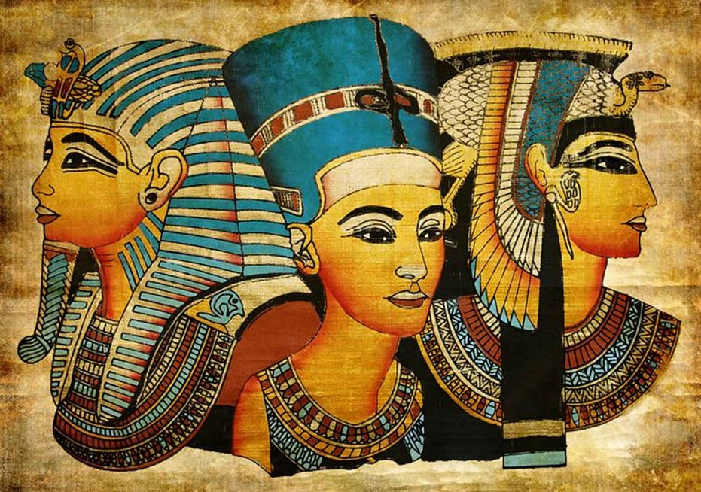

ART / D&T: The children will be designing scarabs, through looking at pictures of original artwork. They will be developing their art skills through sketching artefacts. The children will improve their DT skills through designing model tombs and pyramids.

P.E. The children will be swimming and working on improving their technique and range of strokes. In school we will be learning invasion games starting with basketball

COMPUTING: The children will be learning about e-safety, looking at “netiquette”, copyrights, plagiarism, blogs and the meaning of age-restrictions.

R.E: We will be learning about the story of Creation